1.INTRODUCTION:   
A vehicle that can be powered by an electric motor that draws electricity from a battery and is capable of being charged from an external source and have an electric motor instead of an internal combustion engine.

The Electric Vehicle (EV) is not new, but it has been receiving significantly more attention in recent years. Advances in both EV analytics and battery technologies have led to increased automotive market share. However, this growth is not attributed to hardware alone. The modern mechatronic vehicle marries electrical storage and propulsion systems with electronic sensors, controls, and actuators, integrated closely with software, secure data transfer, and data analysis, to form a comprehensive transportation solution. Advances in all these areas have contributed to the overall rise of EV’s, but the common thread that runs through all these elements is data analytics.

The new EV’s are combined Electrical storage and propulsion systems with electronic sensors, controls, and actuators, integrated closely with software, secure data transfer to form a comprehensive transportation solution.

1.2 Purpose:

Electric vehicles use electricity to charge their batteries instead of using fossil fuels like petrol or diesel. Electric vehicles are more efficient, and that combined with the electricity cost means that charging an electric vehicle is cheaper than filling petrol or diesel for your travel requirements.

Electric vehicles use electricity to charge their batteries instead of using fossil fuels like petrol or diesel. Electric vehicles are more efficient, and that combined with the electricity cost means that charging an electric vehicle is cheaper than filling petrol or diesel for your travel requirements.

2. PROBLEM DEFINITION & DESIGN THINKING;

2.1 Empathy map:

  


2.2 Brainstorming map:



3. RESULT

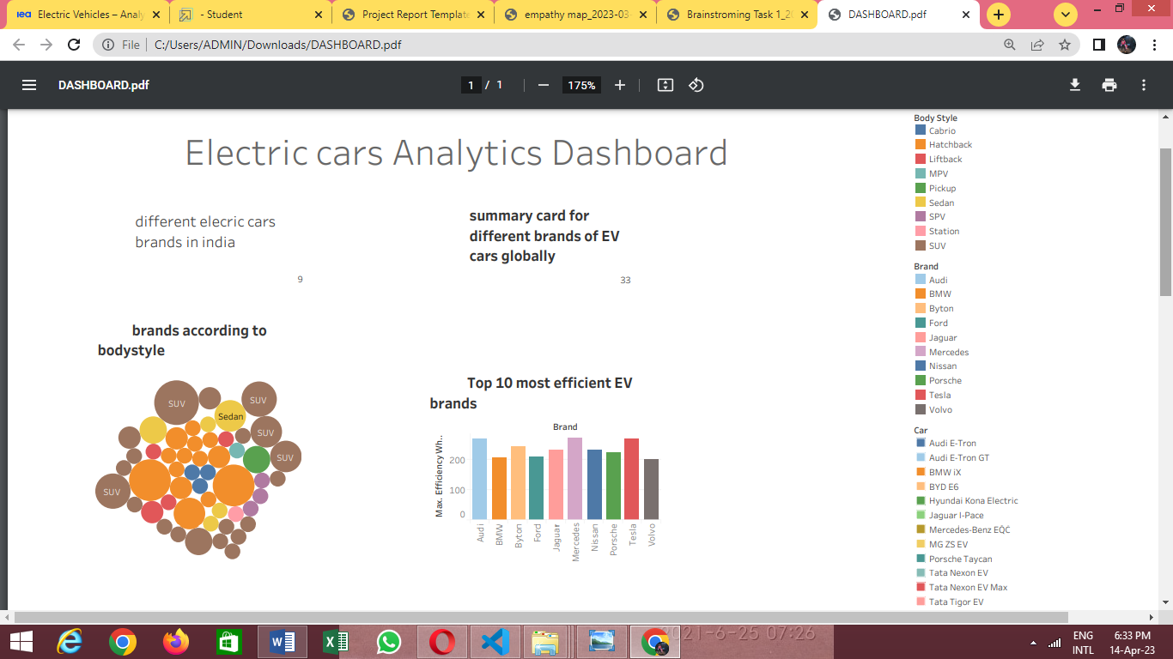

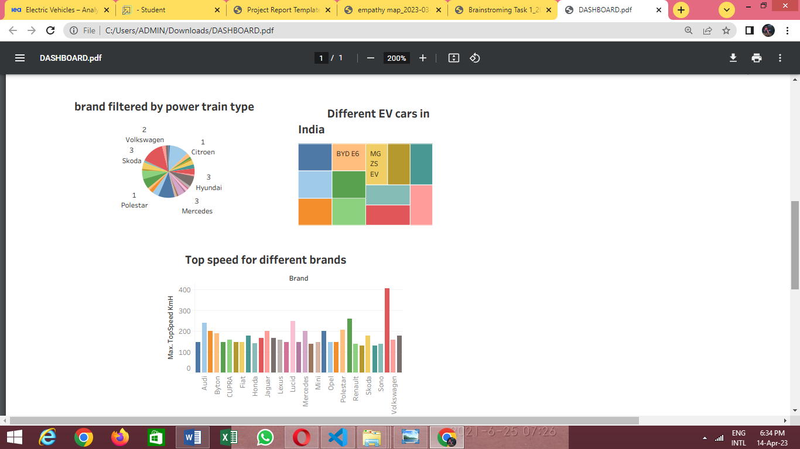

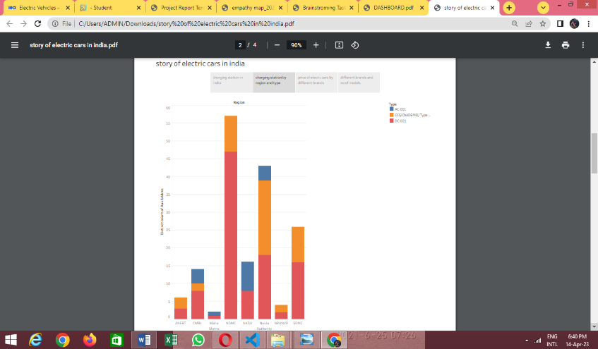

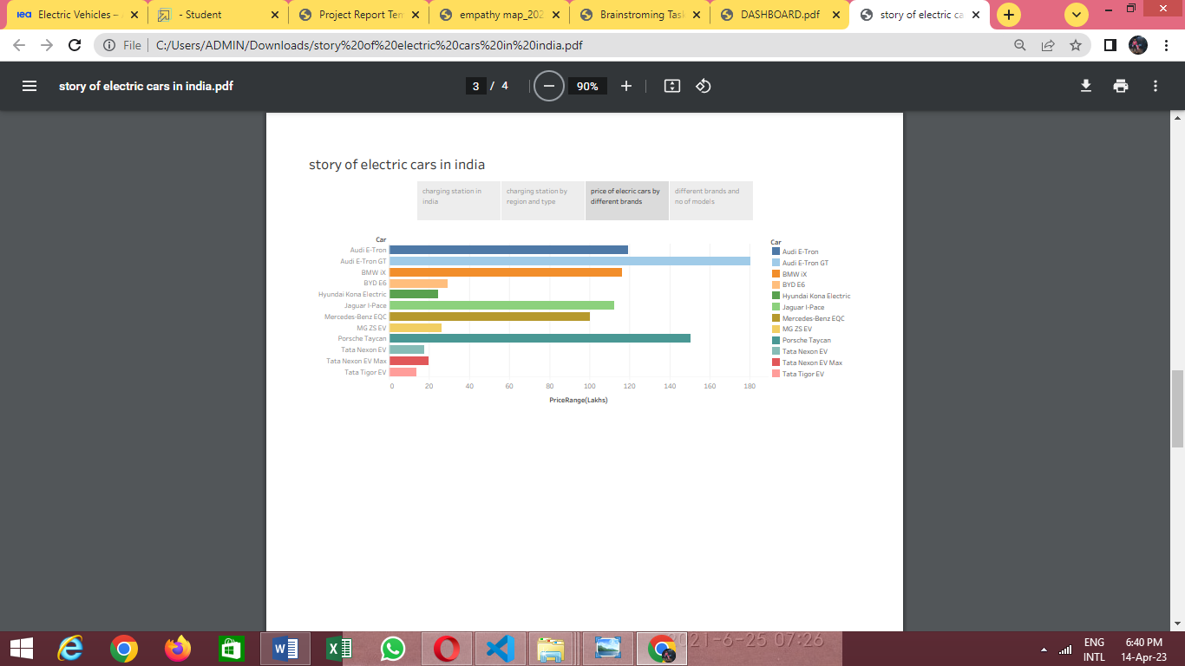

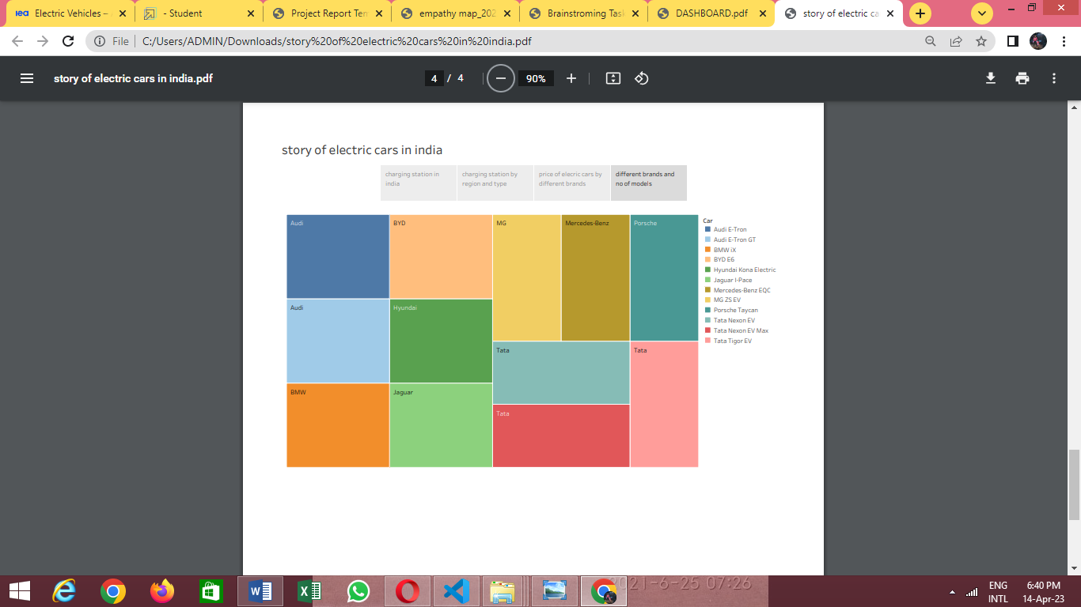

ADVANTAGES DISDVANTAGES

Unlike other vehicles electric vehicle It is higher cost compared

are non-pollutant to other automobile

The vehicle should be easy to maintain Over charging cause fire

It must be comfortable for ride They don’t give enough mileage

It should be long lasting Cannot travel long distance

Nowadays electric vehicles It has low top speed

are made more efficient to travel

It reduces the usage of petrol It take more time to charge

Application;

Electric vehicles use electricity **to charge their batteries** instead of using fossil fuels like petrol or diesel. Electric vehicles are more efficient, and that combined with the electricity cost means that charging an electric vehicle is cheaper than filling petrol or diesel for your travel requirements

Conclusion:

The progress that the electric vehicle industry has seen in recent years is not only extremely welcomed, but highly necessary in light of the increasing global greenhouse gas levels. As demonstrated within the economic, social, and environmental analysis sections of this webpage, the benefits of electric vehicles far surpass the costs. The biggest obstacle to the widespread adoption of electric-powered transportation is cost related, as gasoline and the vehicles that run on it are readily available, convenient, and less costly. As is demonstrated in our timeline, we hope that over the course of the next decade technological advancements and policy changes will help ease the transition from traditional fuel-powered vehicles. Additionally, the realization and success of this industry relies heavily on the global population, and it is our hope that through mass marketing and environmental education programs people will feel incentivized and empowered to drive an electric-powered vehicle. Each person can make a difference, so go electric and help make a difference!

Future scope:

We take our “We grow talent, talent grows us” culture belief to heart by focusing on developing our Moment Makers. An ever-growing Radisson Academy offer aims to equip you with key skills and boost your potential through customized training programs right from your day one. We are dedicated to individual development and have a strong performance culture that facilitates your career growth at all levels